Bridge

🌉 What is a Bridge in Networking?
# Source: AI Source: Provided by: [Data Path: Persons Table -> ID Column: 1, Name_En Column: Motasem Essam] -> From: [ChatGPT] on [12/18/2025]
A Bridge is a Layer 2 (Data Link Layer) network device that is used to connect two or more network segments and make them function as a single network. It filters and forwards traffic based on MAC addresses, reducing collisions and managing traffic intelligently.
✅ Think of it as a device that "bridges" two LANs together.

🔧 What a Bridge Does
# Source: AI Source: Provided by: [Data Path: Persons Table -> ID Column: 1, Name_En Column: Motasem Essam] -> From: [ChatGPT] on [12/18/2025]
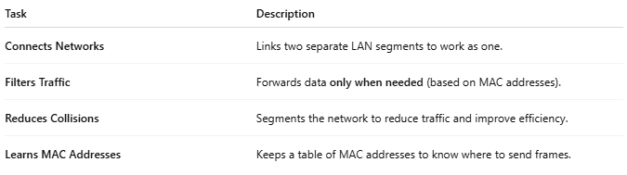
Task | Description
Connects Networks | Links two separate LAN segments to work as one.
Filters Traffic | Forwards data only when needed (based on MAC addresses).
Reduces Collisions | Segments the network to reduce traffic and improve efficiency.
Learns MAC Addresses | Keeps a table of MAC addresses to know where to send frames.

📶 Basic Diagram
# Source: AI Source: Provided by: [Data Path: Persons Table -> ID Column: 1, Name_En Column: Motasem Essam] -> From: [ChatGPT] on [12/18/2025]

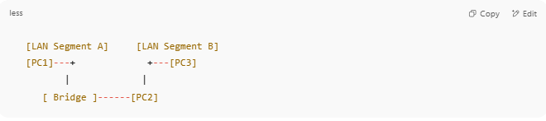
[LAN Segment A] [LAN Segment B]
[PC1]---+ +---[PC3]
| |
[ Bridge ]------[PC2]

- Devices on both sides can communicate.
- The bridge forwards frames only when the destination is on the other segment.

🧱 Where Bridges Are Used
# Source: AI Source: Provided by: [Data Path: Persons Table -> ID Column: 1, Name_En Column: Motasem Essam] -> From: [ChatGPT] on [12/18/2025]

- To segment traffic in large Ethernet networks
- To extend networks across floors or buildings
- In older networks, before switches became common

🆚 Bridge vs Switch
# Source: AI Source: Provided by: [Data Path: Persons Table -> ID Column: 1, Name_En Column: Motasem Essam] -> From: [ChatGPT] on [12/18/2025]

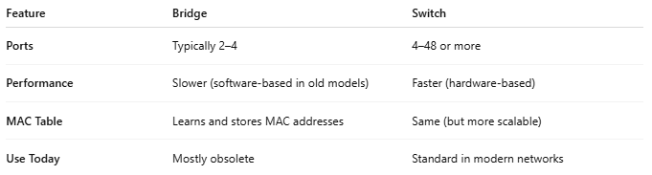
Feature | Bridge | Switch
Ports | Typically 2–4 | 4–48 or more
Performance | Slower (software-based in old models) | Faster (hardware-based)
MAC Table | Learns and stores MAC addresses | Same (but more scalable)
Use Today | Mostly obsolete | Standard in modern networks

🧠 Types of Bridges
# Source: AI Source: Provided by: [Data Path: Persons Table -> ID Column: 1, Name_En Column: Motasem Essam] -> From: [ChatGPT] on [12/18/2025]
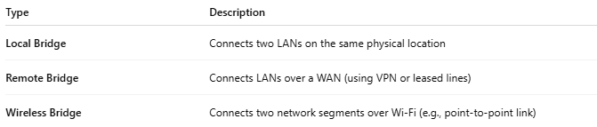
Type | Description
Local Bridge | Connects two LANs on the same physical location
Remote Bridge | Connects LANs over a WAN (using VPN or leased lines)
Wireless Bridge | Connects two network segments over Wi-Fi (e.g., point-to-point link)

✅ Benefits
# Source: AI Source: Provided by: [Data Path: Persons Table -> ID Column: 1, Name_En Column: Motasem Essam] -> From: [ChatGPT] on [12/18/2025]
- ✔ Reduces unnecessary traffic
- ✔ Creates a more efficient LAN
- ✔ Easy to configure in small setups

❌ Limitations
# Source: AI Source: Provided by: [Data Path: Persons Table -> ID Column: 1, Name_En Column: Motasem Essam] -> From: [ChatGPT] on [12/18/2025]
- ❌ Not suitable for large, complex networks
- ❌ Replaced by switches in modern infrastructure
- ❌ Limited port capacity

📌 Summary
# Source: AI Source: Provided by: [Data Path: Persons Table -> ID Column: 1, Name_En Column: Motasem Essam] -> From: [ChatGPT] on [12/18/2025]
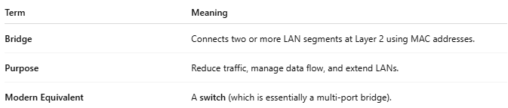
Term | Meaning
Bridge | Connects two or more LAN segments at Layer 2 using MAC addresses.
Purpose | Reduce traffic, manage data flow, and extend LANs.
Modern Equivalent | A switch (which is essentially a multi-port bridge).

